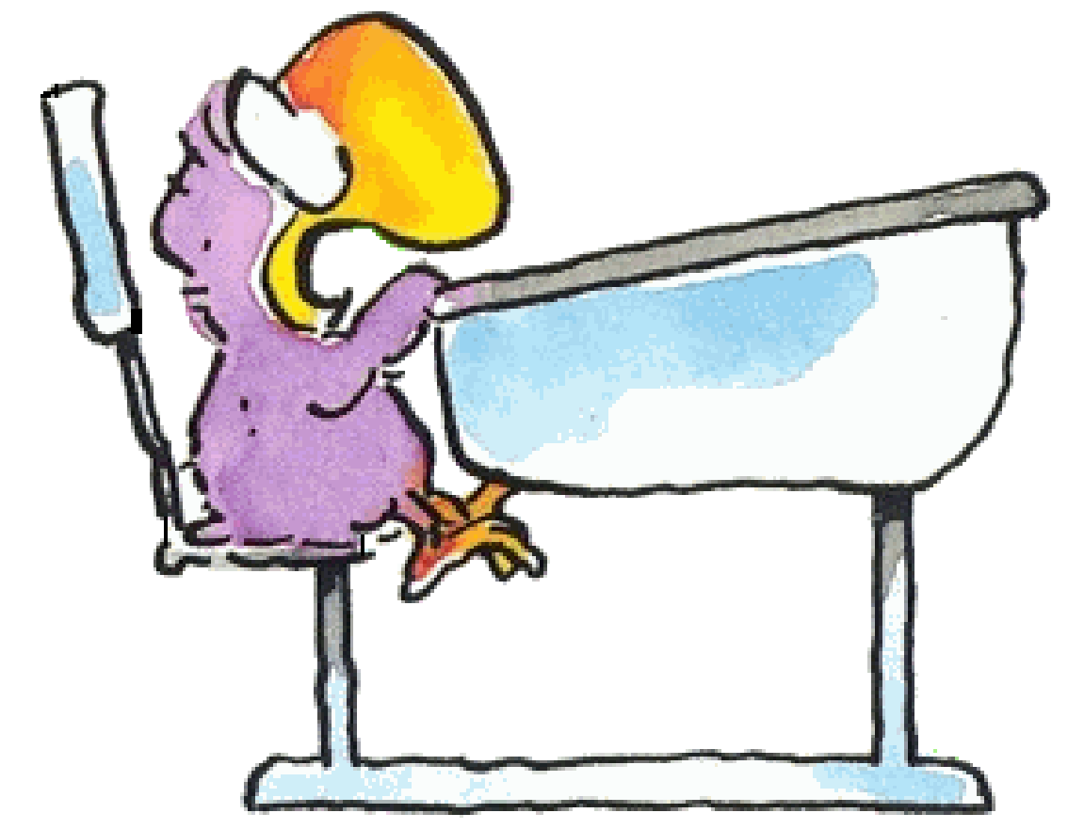
Maaltafels 9, 8 en 6

Ik maak …………………… juiste maaltafels in 1 minuut.

9 x 8 =  7 x 6 =  6 x 9 =  7 x 8 =  8 x 9 =  2 x 9 =  4 x 6 =  4 x 9 =  5 x 8 =  7 x 6 =  6 x 9 =  3 x 8 =  3 x 6 = | 3 x 9 =  9 x 6 =  8 x 6 =  4 x 6 =  4 x 8 =  8 x 9 =  10 x 9 =  8 x 8 =  6 x 9 =  8 x 9 =  7 x 9 =  5 x 9 =  3 x 6 = | 5 x 9 =  8 x 6 =  2 x 8 =  5 x 9 =  6 x 8 =  4 x 6 =  8 x 8 =  2 x 9 =  1 x 8 =  3 x 6 =  4 x 9 =  3 x 8 =  5 x 6 =
Zin van de dag:

